**EECS 118**

**Knowledge Engineering and Software Engineering**

**Fall 2018**

**Term Project**

**Option II: A Geometry Problem Solver**

**Project Supplement**

**Problem Set Q**

You are required to create a separate solver for each one of the following problems. Please use Python 3.5 or above as your programming language for the solver program.

Assigned Problems:

1. Two triangles have two intersection points:

The intersections are on the same side of a triangle. One side of a triangle is inside another triangle.

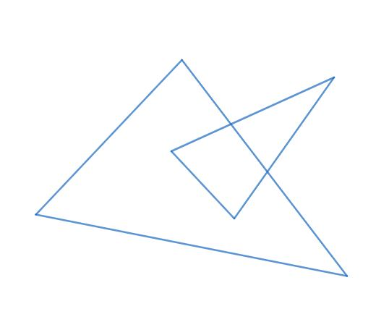

1. Two triangles have three intersection points:

One intersection is on one side of a triangle, two other intersections are on another side. one side of a triangle is completely inside another triangle.

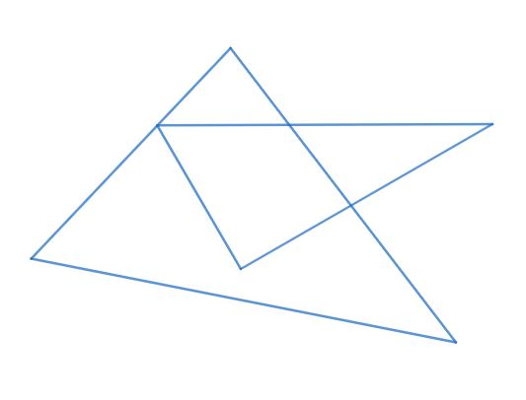

1. A line segment and a triangle have two intersection points:

One intersection is on the one side of the triangle, the other intersection is on a vertex of the triangle.

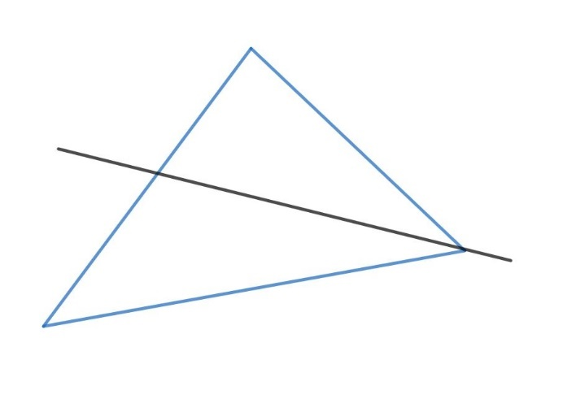

You are encouraged to draw your own diagrams according to the description. The diagrams above are only for your reference, you need to consider all cases as long as they meet the description. Please also consider boundary cases.

Extra Credits:

Instead of creating solvers for the above problems, design a solver that can solve any two triangle problems.

Resources:

[Learn Python in 60 Minutes from Java](https://www.youtube.com/watch?v=xLovcfIugy8)

[How to solve a triangle](https://en.wikipedia.org/wiki/Solution_of_triangles#Solving_plane_triangles): You can start here.

[Law of Sines--Ambiguous Case](http://jwilson.coe.uga.edu/EMT668/EMAT6680.2001/Mealor/EMAT%206700/law%20of%20sines/Law%20of%20Sines%20ambiguous%20case/lawofsinesambiguouscase.html): A special case.

[Single Triangle Calculator](https://www.triangle-calculator.com/): An online demo of single triangle problem solver.

[SymPy Geometry Module](https://docs.sympy.org/latest/modules/geometry/index.html): SymPy is a Python library, you may find its geometry module helpful.